## Semester: V Name of Student:

**Academic Year: 2021-22 Student ID: Class / Branch: TE IT**

## Subject: Advanced Devops Lab (ADL) Name of Instructor: Prof. Manjusha K.

**EXPERIMENT NO. 02**

**Aim: To Build Your Application using AWS CodeBuild and Deploy on S3 / SEBS using AWS CodePipeline, deploy Sample Application on EC2 instance using AWS CodeDeploy.**

# Step1: Create a deployment environment

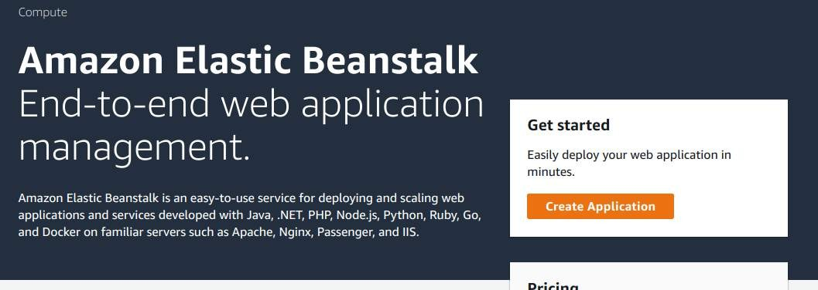

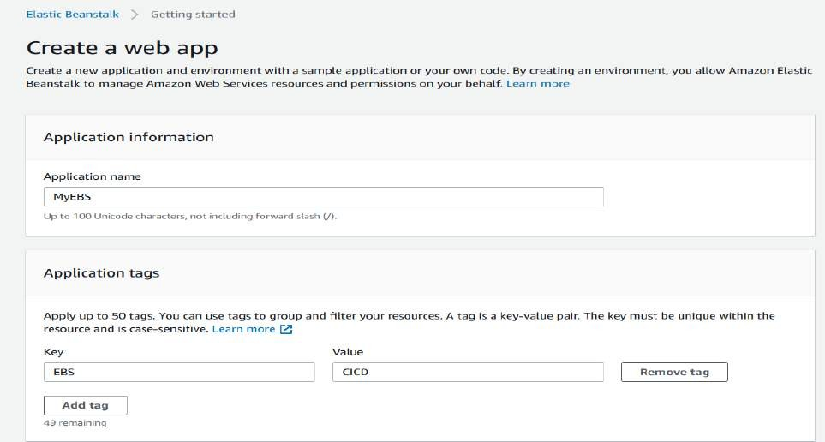

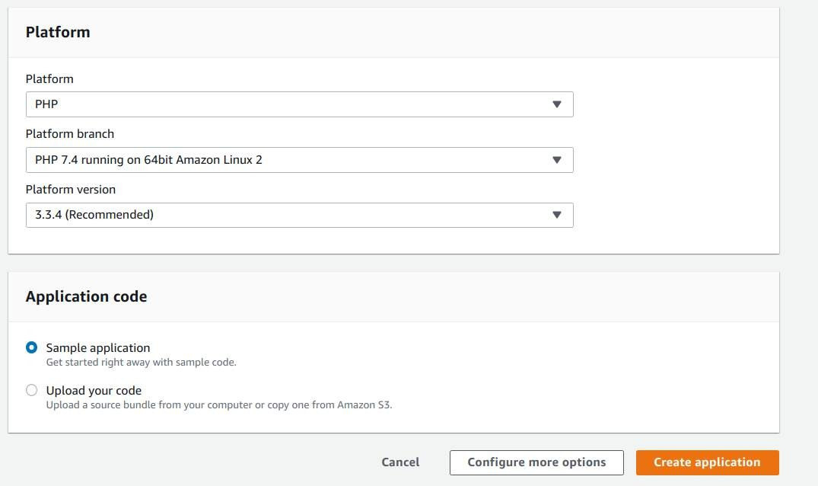

**Step2: Get a copy of the sample code**

In this step, you will retrieve a copy of the sample app’s code and choose a source to host the code.

The pipeline takes code from the source and then performs actions on it.

You can use one of three options as your source: a GitHub repository, an Amazon S3 bucket, or an AWS CodeCommit repository. Select your preference and follow the steps below:

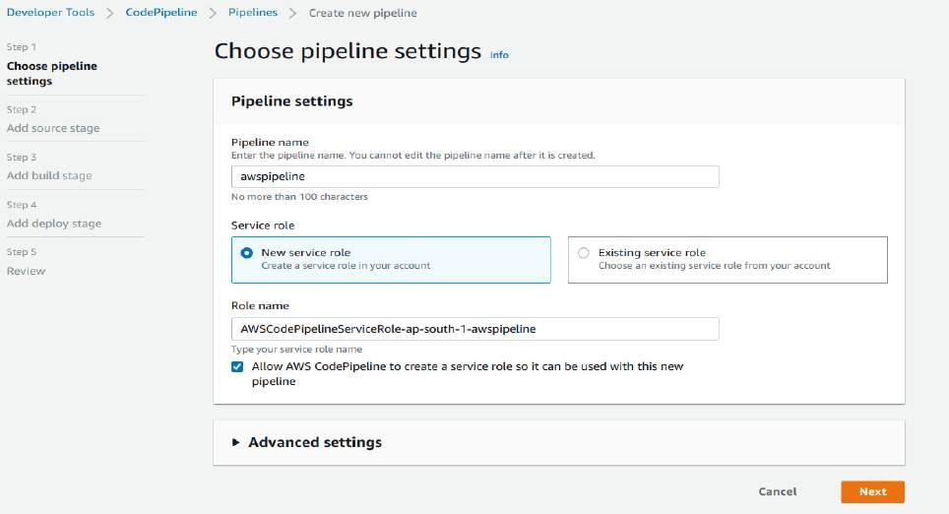

## If you plan to use Amazon S3 as your source, you will retrieve the sample code from the AWS GitHub repository, save it to your computer, and upload it to an Amazon S3 bucket.

* + Visit our GitHub repository containing the sample code at <https://github.com/imoisharma/aws-codepipeline-s3-codedeploy-linux-2.0>
  + Click the dist folder.

## Save the source files to your computer:

* + Click the file named aws-codepipeline-s3-aws-codedeploy_linux.zip
  + Click View Raw.
  + Save the sample file to your local computer.

## open the Amazon S3 console and create your Amazon S3 bucket:

* + Click Create Bucket
  + Bucket Name: type a unique name for your bucket, such as awscodepipeline-demobucket- variables. All bucket names in Amazon S3 must be unique, so use one of your own, not one with the name shown in the example.
  + Region: In the drop-down, select the region where you will create your pipeline, such as ap- South-1
  + Click Create.

## d.The console displays the newly created bucket, which is empty.

* Click Properties.
* Expand Versioning and select Enable Versioning. When versioning is enabled, Amazon S3 saves every version of every object in the bucket.

## e. You will now upload the sample code to the Amazon S3 bucket:

* Click Upload.
* Follow the on-screen directions to upload the .zip file containing the sample code you downloaded from GitHub.

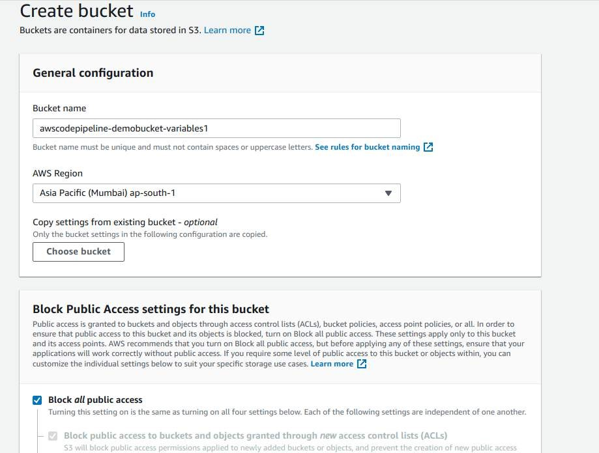

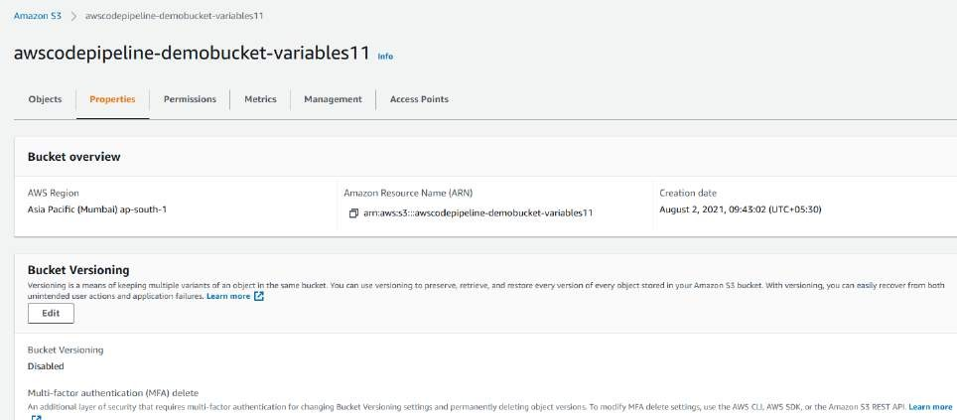

**you can upload directly zip file here from** [**https://github.com/imoisharma/aws-codepipeline-**](https://github.com/imoisharma/aws-codepipeline-s3-codedeploy-linux-2.0)[**s3-codedeploy-linux-2.0**](https://github.com/imoisharma/aws-codepipeline-s3-codedeploy-linux-2.0)

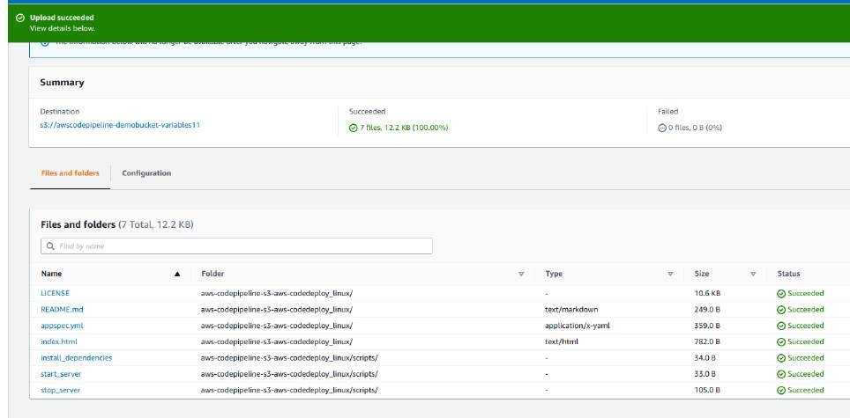

# Step3: Create your Pipeline

In this step, you will create and configure a simple pipeline with two actions: source and deploy. You will provide CodePipeline with the locations of your source repository and deployment environment.

A true continuous deployment pipeline requires a build stage, where code is compiled and unit tested. CodePipeline lets you plug your preferred build provider into your pipeline. However, in this we will skip the build stage.

Goto Pipeline again and create it

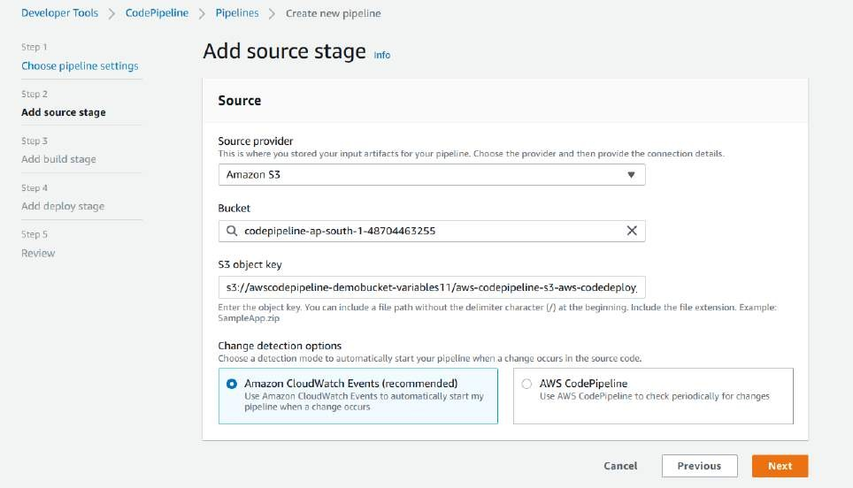

## In above you can give zip file name in S3 object Key and choose bucket name which you created

**In Step 4: Deploy Stage:**

* Deployment provider: Click AWS Elastic Beanstalk.
* Application name: MYEBS.
* Environment name: Click Myebs-env.
* Click Next step.

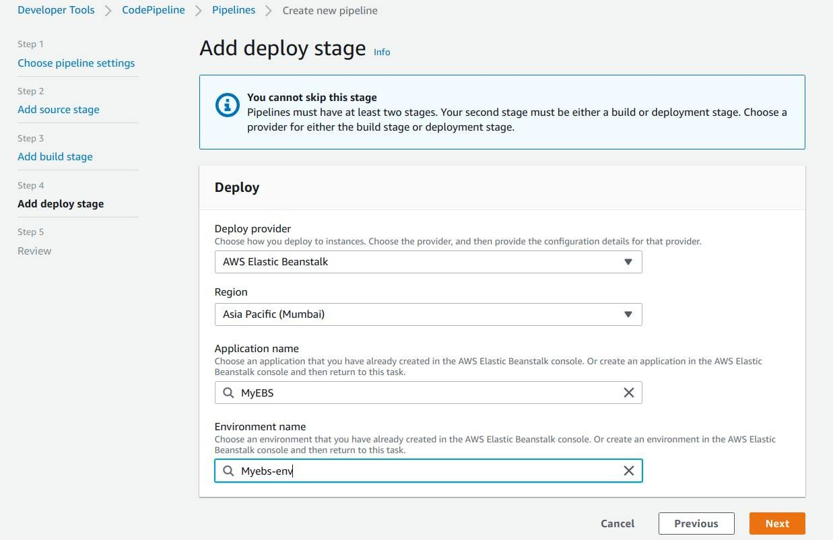

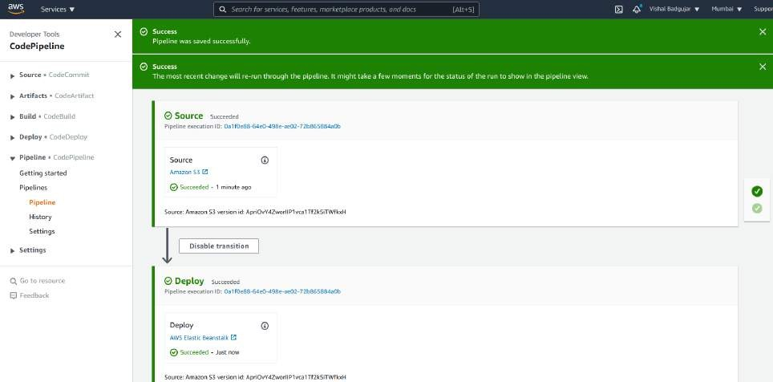

After your pipeline is created, the pipeline status page appears and the pipeline automatically starts to run. You can view progress as well as success and failure messages as the pipeline perform each action.

To verify your pipeline ran successfully, monitor the progress of the pipeline as it moves through each stage. The status of each stage will change from No executions yet to In Progress, and then to either Succeeded or Failed. The pipeline should complete the first run within a few minutes.

Now go to your EBS environment and click on the URL to view the sample website you deployed.

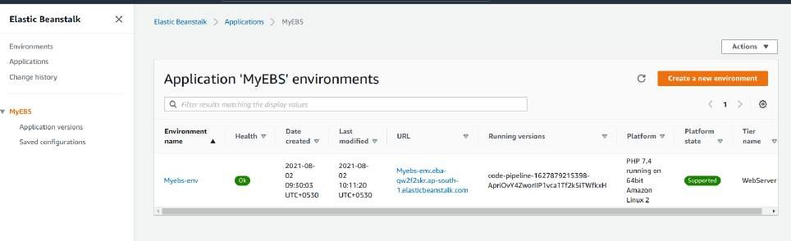

You have successfully created an automated software release pipeline using AWS CodePipeline!

Using CodePipeline, you created a pipeline that uses GitHub, Amazon S3, or AWS CodeCommit as the source location for application code and then deploys the code to an Amazon EC2 instance managed by AWS Elastic Beanstalk.

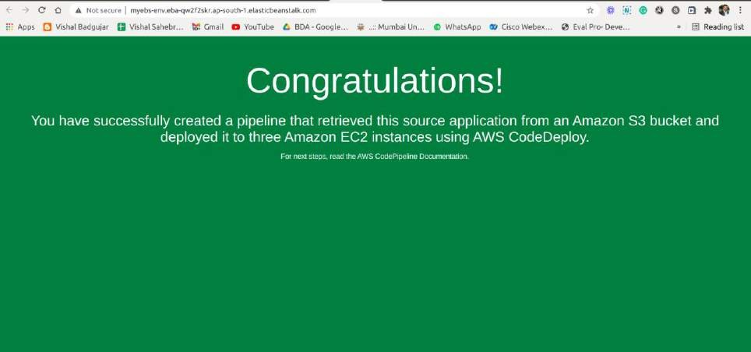

# Step 5: Commit a change and then update your app Step 6: Clean up your resources

To avoid future charges, you will delete all the resources you launched throughout this tutorial, which includes the pipeline, the Elastic Beanstalk application, and the source you set up to host the code.

1. First, you will delete your pipeline:
2. Second, delete your Elastic Beanstalk application:

## Conclusion: Write your own findings.